
QUALITY ALERT

Customer: ORAN Date: Nov 15, 2023
Die: 15354A Colour: All
Type of Complaint: ORAN REJECTED

Q.A # Q.I.R # CUSTOMER NCR #

Description: Customer REJECTED, Nail Fin was NOT cut, makes it not fit the punch.
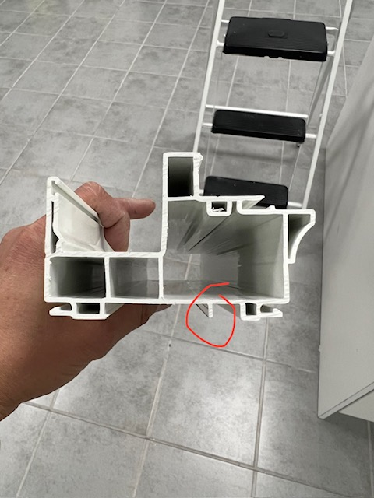
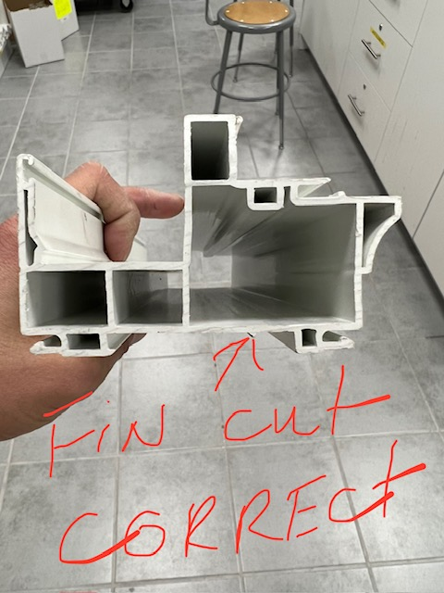

BAD
GOOD

MAKE SURE FIN MUST BE CUT FLUSH
APPLY TO ALL ORAN DIES

BY SIGNING BELOW, YOU ACKNOWLEDGE THE PROBLEM ABOVE AND AGREE TO MONITOR THIS ISSUE IN FUTURE PRODUCTION RUNS.
DAY SHIFT |  | AFTERNOON SHIFT |  | NIGHT SHIFT
NAME | SIGNATURE | NAME | SIGNATURE | NAME | SIGNATURE

